**A**

**PROJECT REPORT ON**

**“CALENDER APPLICATION”**

SUBMITTED BY:

**Miss. Hande Grishma Kishor (2124UCEF1061)**

SUBJECT:

**C++ PROGRAMMING**

Under the guidance of

# Miss. ISHWARI TIRSE



**Department of Computer Science and Engineering**

**Sanjivani Rural Education Society’s**

# SANJIVANI UNIVERSITY

**KOPARGAON-423603, DIST: AHMEDNAGAR**

**2024-2025**

|  |  |  |
| --- | --- | --- |
| **SR.**  **NO** | **CONTENT** | **PAGE NO.** |
| **1.** | **INTRODUCTION** | **3** |
| **2.** | **CODE** | **4** |
| **3.** | **OUTPUT** | **7** |
| **4.** | **CONCLUSION** | **8** |

## INTRODUCTION

The Calendar Application is a console-based mini-project developed in C++ that allows users to manage events for specific dates. It includes features like adding, viewing, and deleting events, along with displaying a calendar for any given month and year. The project demonstrates practical usage of data structures and date calculations in C++, providing an interactive tool to organize schedules efficiently. This project is simple yet effective for learning core programming concepts and can be extended with additional functionalities like recurring events or data storage.

## CODE

#include <iostream>

using namespace std;

bool isLeapYear(int year) {

if (year % 400 == 0)

return true;

if (year % 100 == 0)

return false;

if (year % 4 == 0)

return true;

return false;

}

int getDaysInMonth(int month, int year) {

switch (month) {

case 1: return 31;

case 2: return isLeapYear(year) ? 29 : 28;

case 3: return 31;

case 4: return 30;

case 5: return 31;

case 6: return 30;

case 7: return 31;

case 8: return 31;

case 9: return 30;

case 10: return 31;

case 11: return 30;

case 12: return 31;

default: return 0;

}

}

int calculateStartDay(int month, int year) {

int day = 1, m = month, y = year;

if (m < 3) {

m += 12;

y -= 1;

}

int k = y % 100;

int j = y / 100;

int startDay = (day + 13 * (m + 1) / 5 + k + k / 4 + j / 4 + 5 * j) % 7;

return (startDay + 5) % 7 + 1;

}

void displayCalendar(int month, int year) {

cout << " Calendar - " << month << "/" << year << endl;

cout << " Sun Mon Tue Wed Thu Fri Sat" << endl;

int daysInMonth = getDaysInMonth(month, year);

int startDay = calculateStartDay(month, year);

for (int i = 1; i < startDay; i++) {

cout << " ";

}

for (int day = 1; day <= daysInMonth; day++) {

printf("%5d", day);

if ((startDay + day - 1) % 7 == 0) {

cout << endl;

}

}

cout << endl;

}

int main() {

int month, year;

cout << "Enter month (1-12): ";

cin >> month;

cout << "Enter year: ";

cin >> year;

if (month < 1 || month > 12 || year < 1) {

cout << "Invalid input!" << endl;

return 1;

}

displayCalendar(month, year);

return 0;

}

## 

## OUTPUT

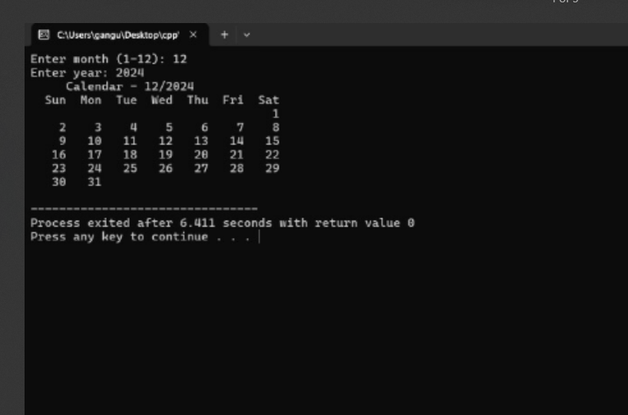

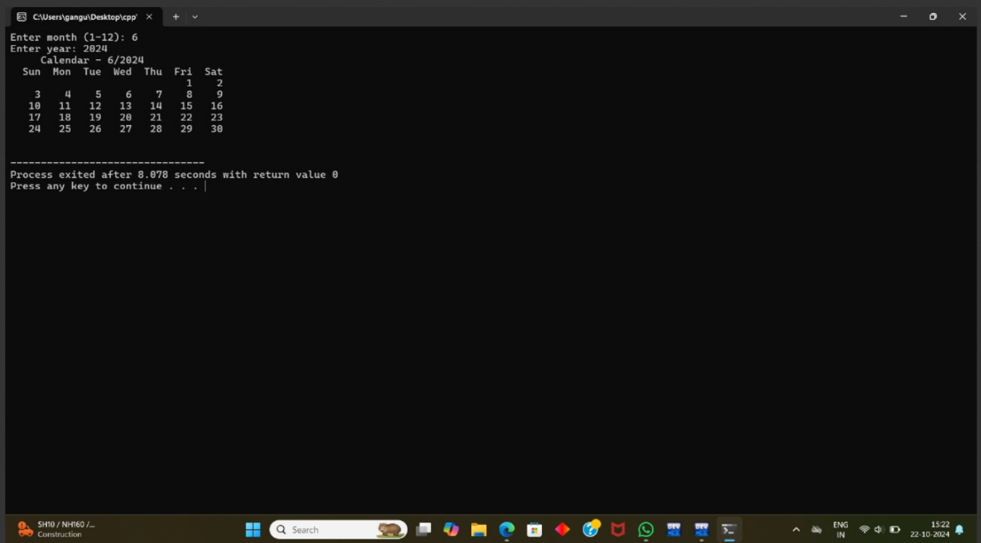

## CONCLUSION

The Calendar App project shows how basic C++ programming ideas can be used to create useful, easy-to-use applications. By including stuff like adding, checking out, and removing events, the project gives a handy tool for keeping track of schedules. It also boosts problem-solving skills by using data structures, handling dates, and making interactive user interfaces. Plus, this project lays a good groundwork for more improvements, like adding events that repeat or saving info to files so it sticks around. All in all, it gives a great learning chance for developers.